6th International Workshop on the History of Human Genetics:
Human Gene Mapping; Oral History of Human Genetics.

In 2015, the 6th International Workshop on the History of Human Genetics took place as a satellite symposium of the annual Conference of the European Society of Human Genetics (ESHG) and was supported by it. The aim of the workshops is that human geneticists meet with historians, philosophers and other social scientists. The first workshops of this series were in Birmingham (2003), Brno (2005), Barcelona (2008), Gothenburg (2010) and Nuremberg (2012).
On Thursday, June 4th, 2015, the workshop started with
Showcase Display & Behind the Scenes Tour: University of Glasgow Archive Services.
This is the central place of deposit for the records created and accumulated by the University since its foundation in 1451, with the oldest charters dating from 1304. In total, Archive Services holds over 1000 collections spanning more than seven countries. The delegates from the ESHG workshop were offered a showcase display of gems from the Modern Genetics collections, like the papers of Guido Pontecorvo, James Renwick and Malcolm Ferguson Smith. Also were shown most valuable items of the Archive like the record of Adam Smith as student and professor at the university as well as the logbook from Lord Nelson’s ship HMS Medusa.
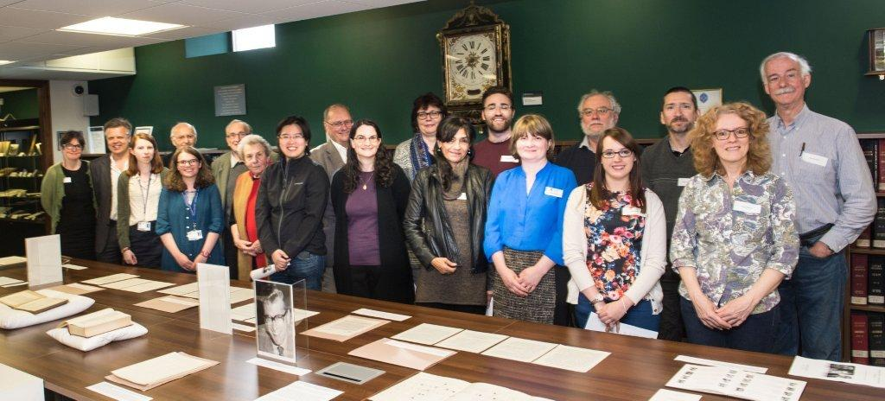
We thank Sam Maddra and her colleagues for the pleasant time at the archive.
On Friday, June 5th, 2015 the workshop started with a session on Human Genetics in Glasgow. In four talks some aspects were highlighted. Malcolm Ferguson-Smith talked about the “Glasgow contribution to the human gene mapping project, 1959-1987”. Then Paula Blair talked about “Pontecorvo’s Legacy''. Kevin O’Dell gave some details of “James Renwick and the first Human Genetic Maps'', before Darren Monckton closed with “Glasgow 2015 and beyond”.
The next topic was Human Gene Mapping with contributions of Alan Rushton “The First Human Genetic Map 1936”, Michael McGovern “The London/Baltimore link has been severed: Human Linkage Mapping and the Early Computerization of Genetics” and Andrew Hogan, “The Thrill of Mapping: Bridging the Gap in Post-war Human Genetics”.
On Friday afternoon, the focus was on the History of Human Genetics and its different aspects. The talks were given by Mauro Capocci (“Unravelling the Complexity of HLA”), Judith Friedman (“The Enduring Puzzle of Leber’s Hereditary Optic Neuropathy”), Reed Pyeritz (“A brief History of Uncertainty in Genomic Medicine”), Karen Birmingham (“Marcus Pembrey Recalls the Catalyst), Aaro M. Tupasela (“Clinical Inquiry into Rare Disease Research in Finland”), Elisa Houwink (“The History of Human Gene mapping”) and Michal Simunek (“Project Documenting the Development of Medical Genetics in Czechoslovakia after 1945).
The Dinner of the Workshop was at Jamie Olivier’s Italian Restaurant in Glasgow. There we enjoyed Italian food and intensive communication with each other.
On Saturday, June 6th, 2015, the topic was Oral History of Human Genetics. The introductory lecture was given by Tilli Tansey. Then five speakers reported about their experiences: Peter S. Harper on “Interviews with Human and Medical Geneticists”, Heike Petermann on “Reflections on Ethical and Theoretical Aspects of Oral History of Human Genetics in Germany”, Christopher Donohue about “The Oral History Initiative at the National Human Genome Research Institute (NHGRI)”, Susanne Doetz on “The Use of Oral History to Explore the Establishment of Genetic Counselling in the GDR during the 1970s and 1980s” and closing Miguel Garcia-Sancho “A Critical Triangulation: the Combination of Archival Sources and Oral Histories in the Investigation of Contemporary Genetics”.
Also there were presented eight posters on different aspects: Ana Barahona on “Medical Genetics in Mexico”, Constantinos Morfakis on “Human Gene Mapping… in the most popular Greek newspapers”, Heike Petermann on “Changing the Point of View: the History of Human Genetics in the Federal Republic of Germany from 1945 to 1975”, Victoria Sloyan on “Collecting Genomics at the Wellcome Library”, Tilli Tansey and Emma M. Jones on “Witnesses to Medical Genetics” and Mapping the Gene Mapping Workshops”, last but not least Carla van El on “Neonatal Screening”.
One Poster was on publication on the History of Human Genetics with contributions of the different workshops. This was meanwhile realized and will be published in April / May 2017.
In all there were 30 participants at the workshop in Glasgow. Most of those did not know each other, so there was interesting communication and exchange during the workshop.
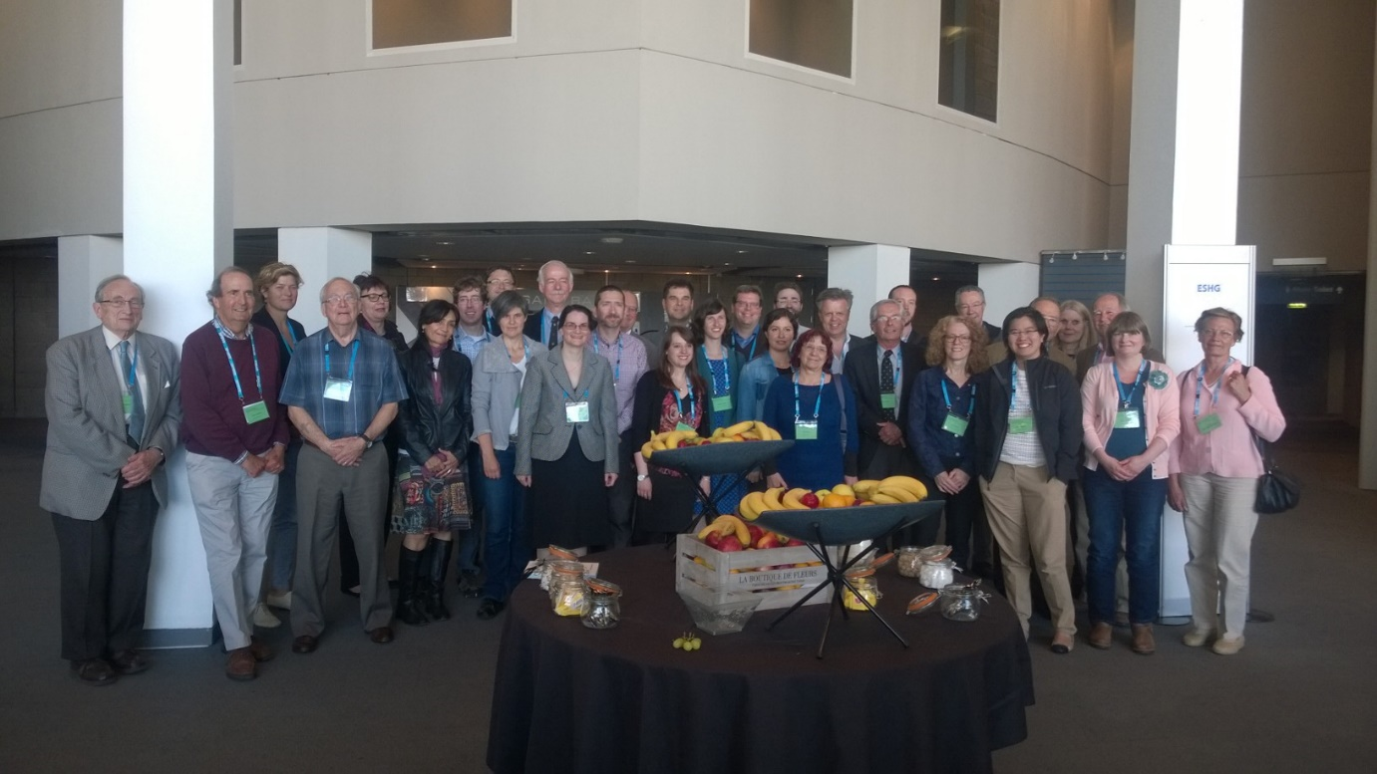
The next workshop will take place in 2017, when the 50th anniversary of the ESHG will be celebrated.

Heike Petermann

